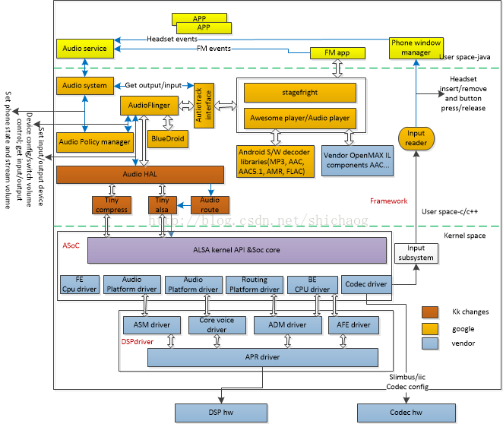
mainly divided into four levels: 1. The lowest layer is the hardware layer; 2. Above this is the driver layer. This layer generally gives a basic driver example to the codec chip; 3. Above this is the Linux framework Layer, ALSA, 4. Above this is the Android audio management layer;

Audio Output Stream and Volume Control:

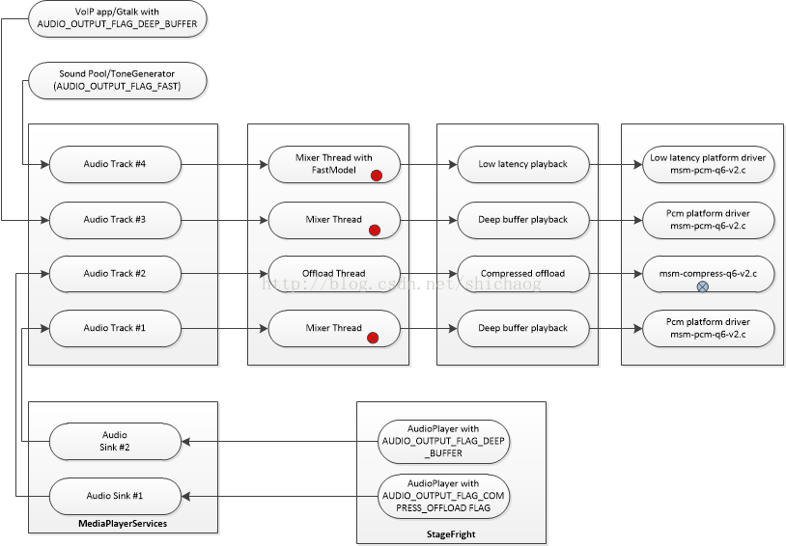
- The default audio output (primary output) uses the Mixer thread in AudioFlinger. The volume and sound effects will be used in Flinger.
- Lowlatency output uses fast mixer in AudioFlinger with volume control in Flinger
- Compress offload playback uses the compress offload thread in Audio Flinger, with volume and sound effects in the DSP.
- VoIP plays mixerThread, Volume and echo cancelation in AudioFlinger by DSP.

Device and flow management:

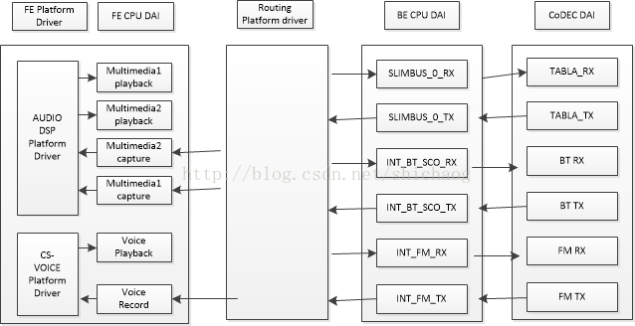
The model of the asoc audio subsystem is shown below:
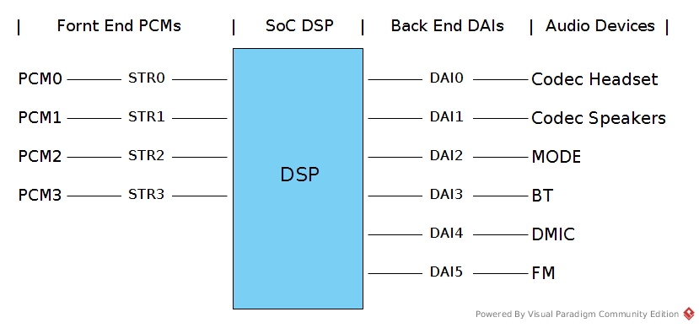

For the msm8996 platform, or all current mobile phone platforms, the hardware model is basically this:
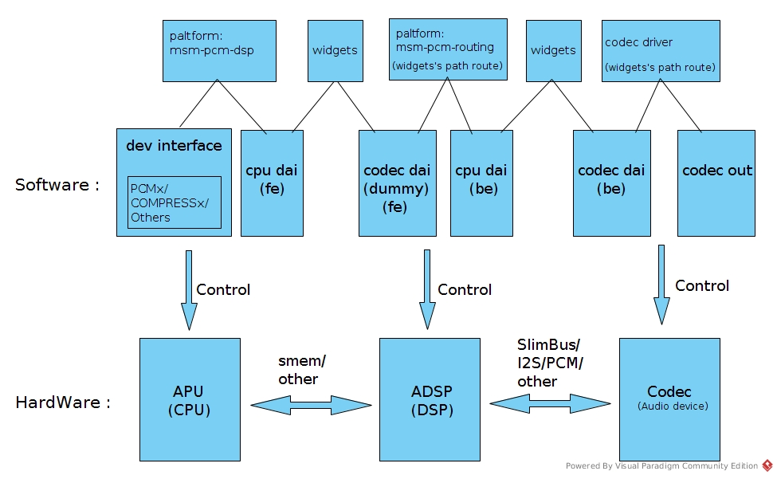
In general, the start of an audio link is divided into 5 parts:

Start
pcm open
hw/sw parameter
prepare
trigger
write
End

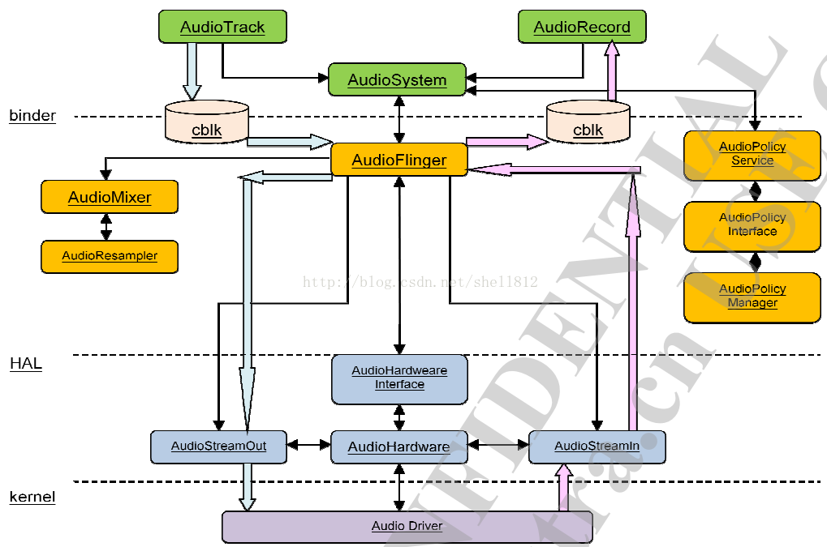
Framework diagram of the audio system

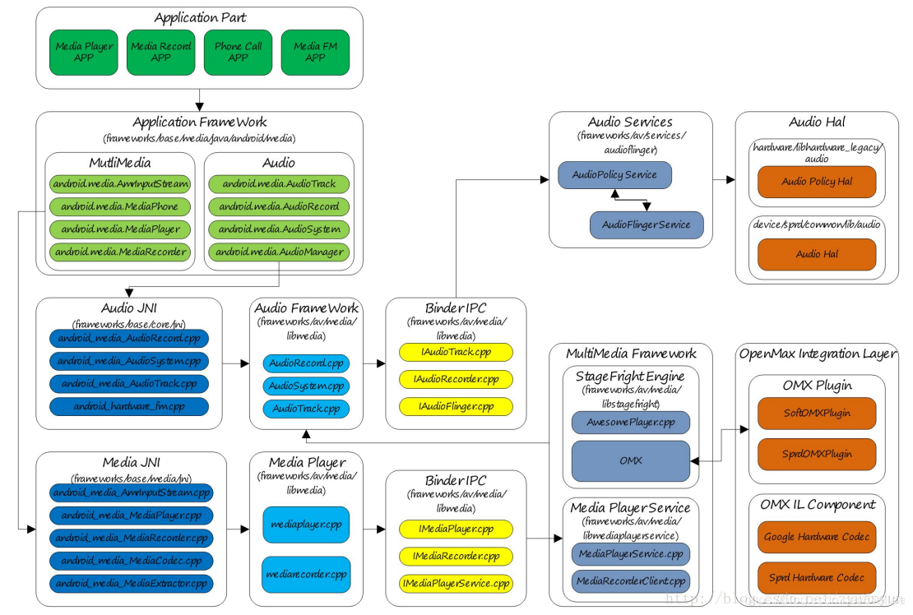

Android audio framework overview

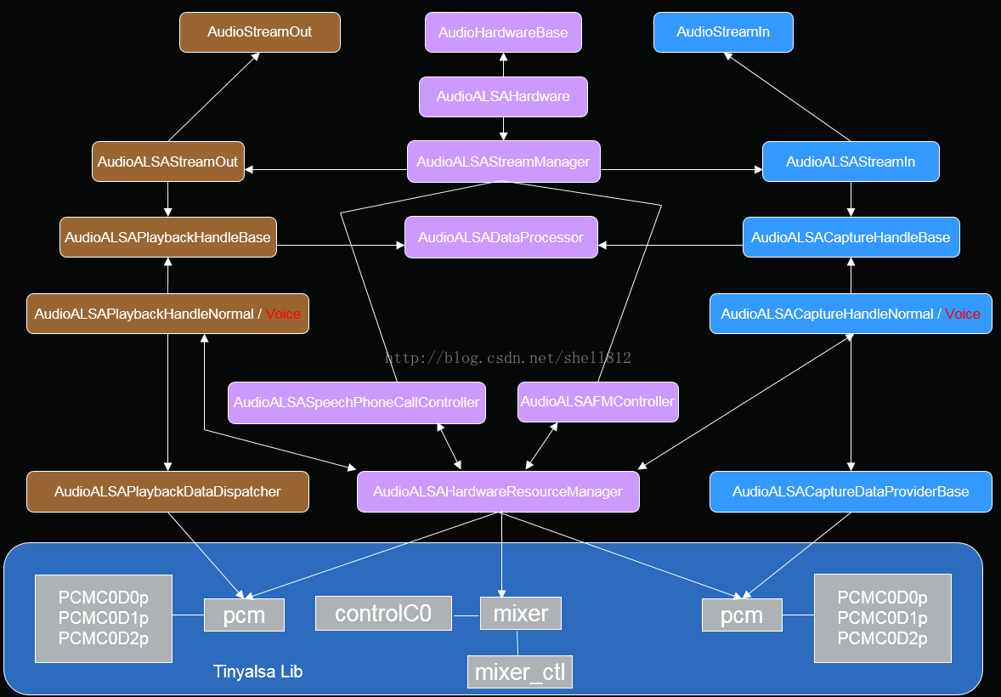
Hal diagram of the audio system
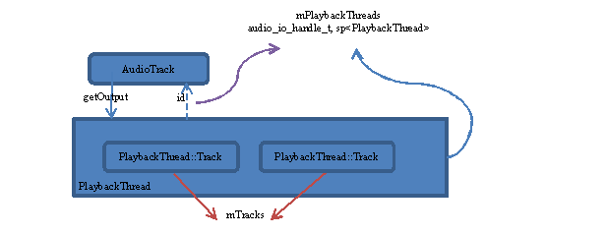

Management of PlaybackThread: Track

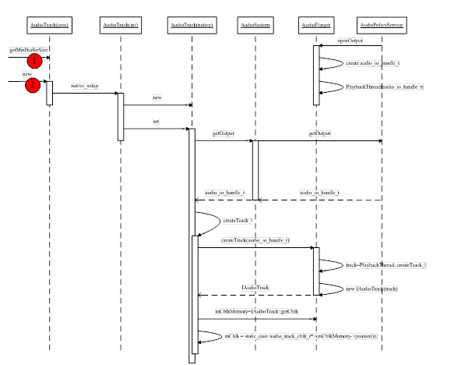

AudioTrack creation process

Relationship between PlaybackThread and output stream device: PlaybackThread instance corresponds to output stream device one by one. For example, OffloadThread will only output audio data to the compress_offload device, and MixerThread (with FastMixer) will only output audio data to low_latency device.
The following figure briefly describes the correspondence between AudioTrack, PlaybackThread, and output stream devices:
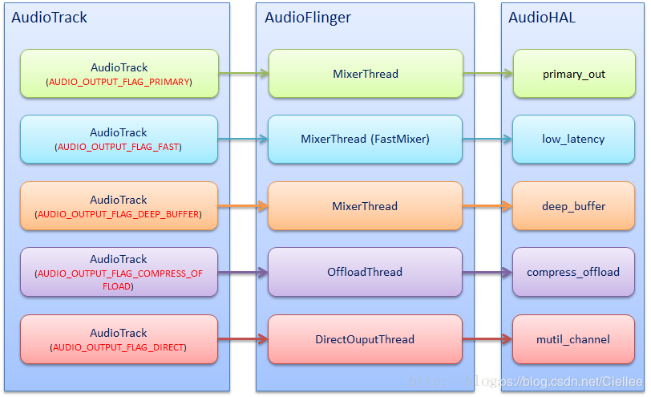

When the system is started, three output stream devices, primary_out, low_latency, and deep_buffer, have been opened, and corresponding MixerThreads have been created. At this time, DirectOutputThread and OffloadThread will not be created until the audio stream identified by AUDIO_OUTPUT_FLAG_DIRECT / AUDIO_OUTPUT_FLAG_COMPRESS_OFFLOAD needs to be output. Only then did the creation of DirectOutputThread / OffloadThread and turn on the direct_out / compress_offload device.

I wonder if everyone here: Why are DirectOutputThread and OffloadThread treated separately?
The usage of DirectOuputThread is low, it is understandable,
but the usage of OffloadThread is still very high, why not let the OffloadThread / compress_offload device also enter the standby state?
To answer this question:
we must first understand what the compress_offload device is and how it differs from other output stream devices.
First look at the picture:

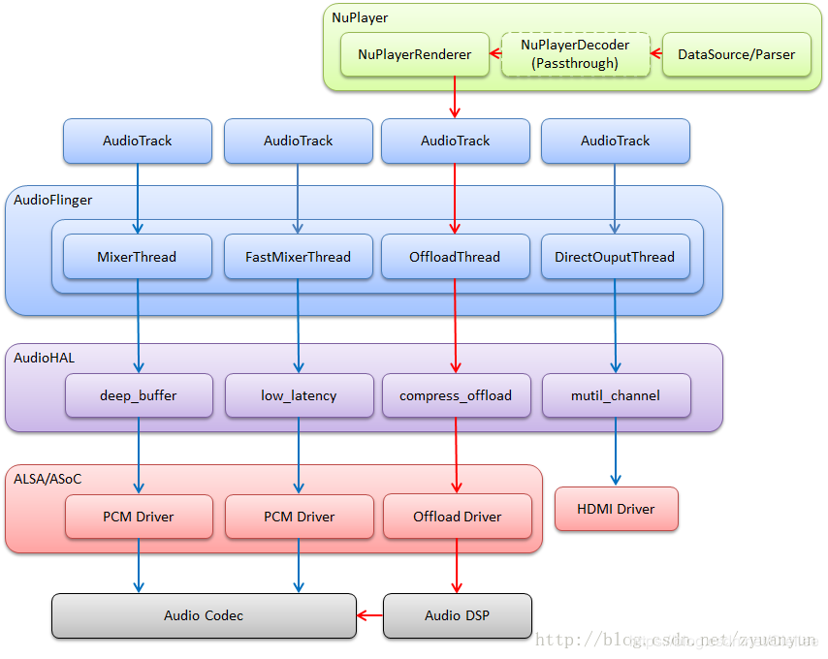
red is the Offload audio stream, how is it different from other audio streams?
Offload audio streams are not decoded by NuPlayerDecoder (NuPlayerDecoder is set to Passthrough mode),
so these audio stream data must be sent to the DSP, which is then decoded by the DSP, and the decoded PCM data is sent to Codec for output.
The compress_offload device, to put it plainly, is to drive the DSP to decode data and Codec to output sound.
To decode data, the DSP must first know the encoding information of the data, such as encoder codec_id, sample rate sample_rate, channel_mask, and bit rate bit_rate. Since the DSP does not implement the DataSource / Parser component, it cannot parse the data encoding itself. Information, so someone has to tell it that this person is undoubtedly the compress_offload device.

Audio playback requires AudioTrack to write audio data and AudioFlinger to complete mixing. Therefore, a data channel needs to be established between AudioTrack and AudioFlinger. AudioTrack and AudioFlinger belong to different process spaces. The Android system uses Binder communication to build them. Between the bridges.
When AudioTrack in the application process requests AudioFlinger to create a Track object in a PlaybackThread, AudioFlinger first creates a Client object for the application process, and at the same time creates a 2M shared memory. When creating a track, the track will allocate buffers in 2M shared memory for audio playback.

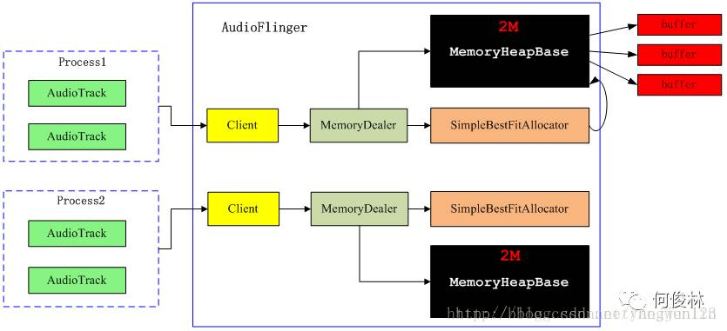
AudioPolicyService and AudioFlinger are the two basic services of the Android audio system. The former is the maker of the audio system strategy, responsible for the audio equipment switching strategy selection, volume adjustment strategy, etc .; the latter is the executor of the audio system strategy, responsible for the management of audio streaming equipment and the processing and transmission of audio stream data. Think of as the engine of the Android audio system.
From Audio HAL, we usually see the following 4 output stream devices, which correspond to different playback scenarios:

primary out: a primary output stream device for ringtone sound output, corresponding to the audio stream identified as AUDIO OUTPUT FLAG PRIMARY and a MixerThread playback thread instance
- low latency: low-latency output stream device, used for sound output with high latency requirements such as keypad sounds and game background sounds, corresponding to the audio stream identified as AUDIO OUTPUT FLAG FAST and a MixerThread playback thread
- deep buffer: music track output stream device, used for music and other low-delay sound output, corresponding to the audio stream identified by AUDIO OUTPUT FLAG DEEP_BUFFER and a MixerThread playback thread instance
- compress offload: a hard-decompressed output stream device for data output that requires hardware decoding, corresponding to the audio stream identified as AUDIO OUTPUT FLAG COMPRESS_OFFLOAD and an OffloadThread playback thread instance

AudioTrack and AudioFlinger communication mechanism
Usually, AudioTrack and AudioFlinger are not in the same process, they establish a connection through the binder mechanism in android. AudioFlinger is a service in android, which is already loaded when android starts.
We can understand this:
- audio track cblk_t implements a circular FIFO;
- AudioTrack is the data producer of FIFO;
- AudioFlinger is a data consumer of FIFO.

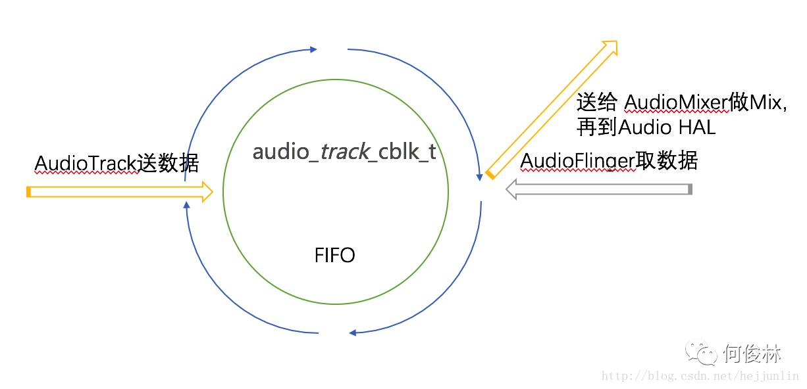
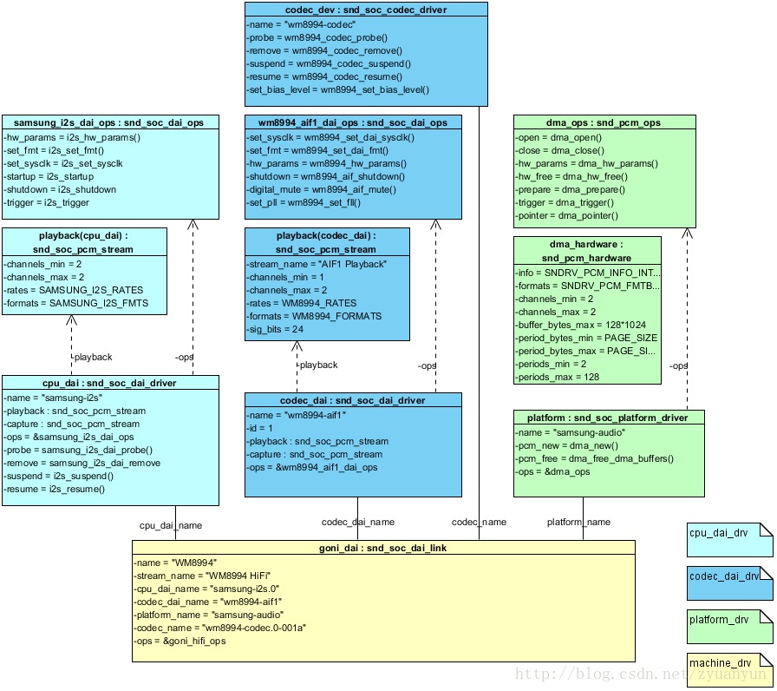
Let's first look at the hardware block diagram of Codec, taking WM8994 as an example:

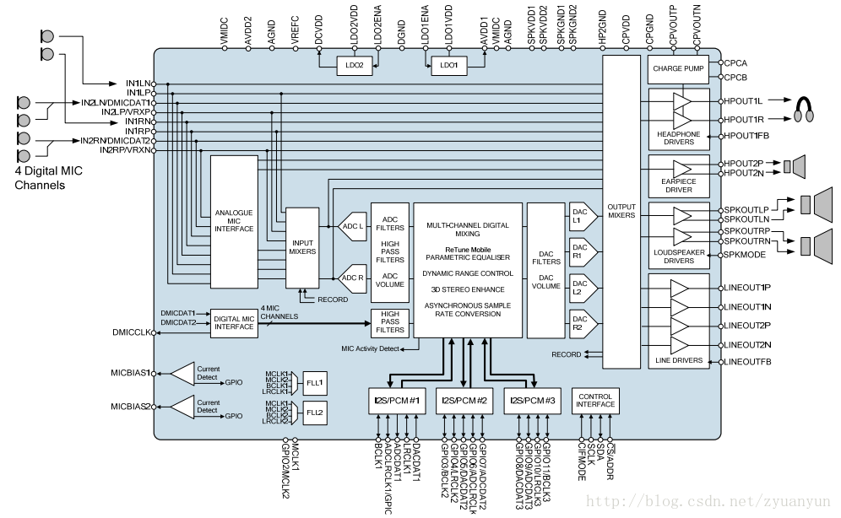

The following is the multimedia playback channel:
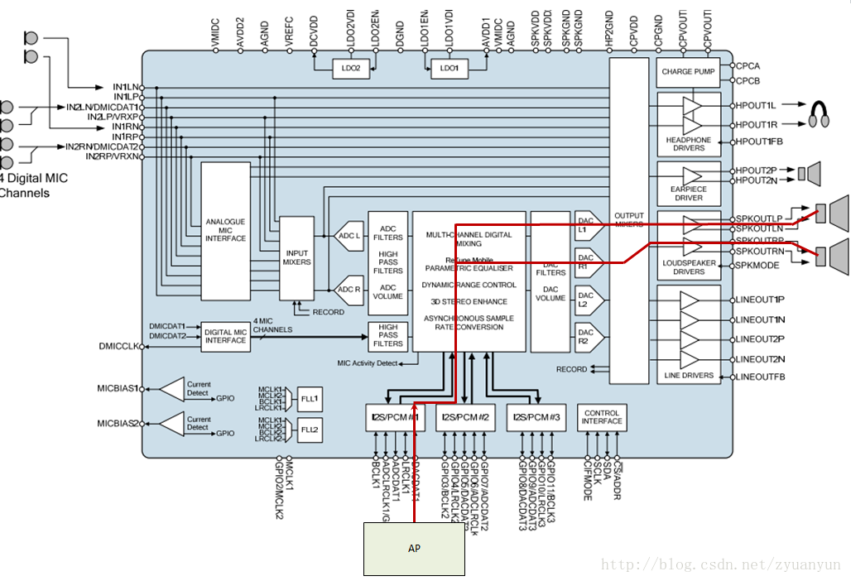

How to create dapm widget and dapm route in the driver? Take the most typical mixer widget as an example: Mixes several analog signals into a single analog signal. It can mix several analog signals into one output, such as SPKMIXL of WM8994:

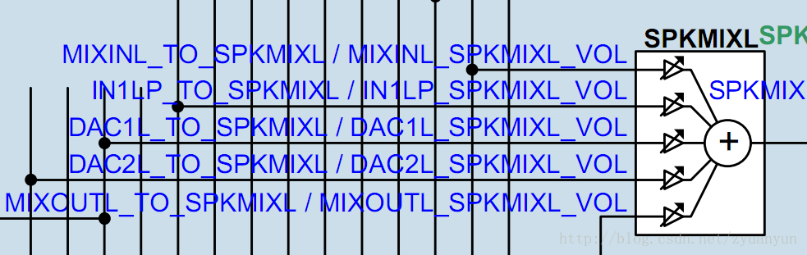

Let's take a look at several important structures in platform_drv. The light blue part is related to cpu_dai, and the light green part is related to pcm_dma. snd_soc_daiThese are dai instances created during snd_soc_platformcpu_dai registration and platform instances created during pcm_dma registration. These instances are convenient for soc-core management

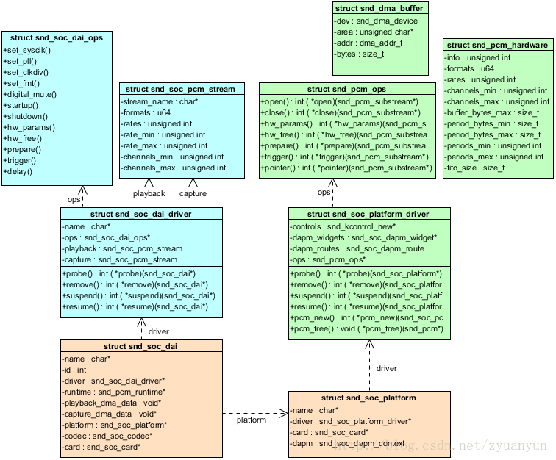

The original intention of writing this document is to describe the pcm data flow clearly. Here we analyze the pcm_dma driver first for later analysis of pcm native. Take the Exynos platform as an example, the code location sound/soc/samsung/dma.c

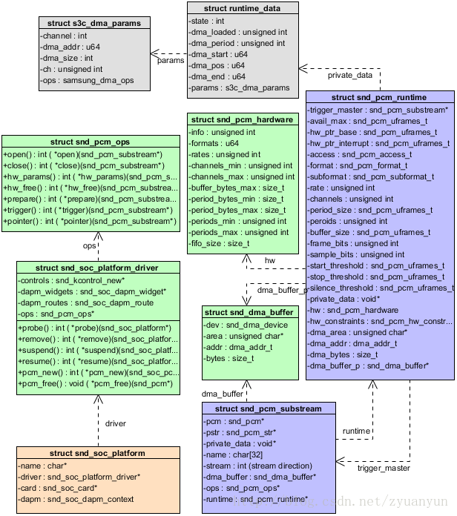

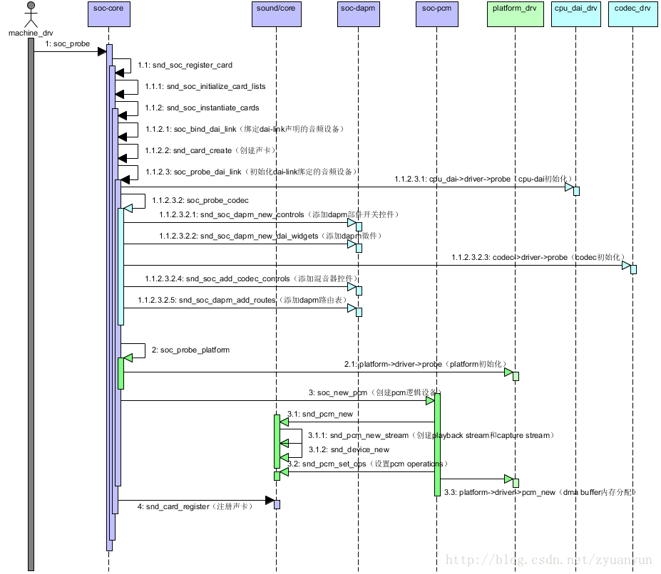

https://blog.csdn.net/zyuanyun/article/details/59170418

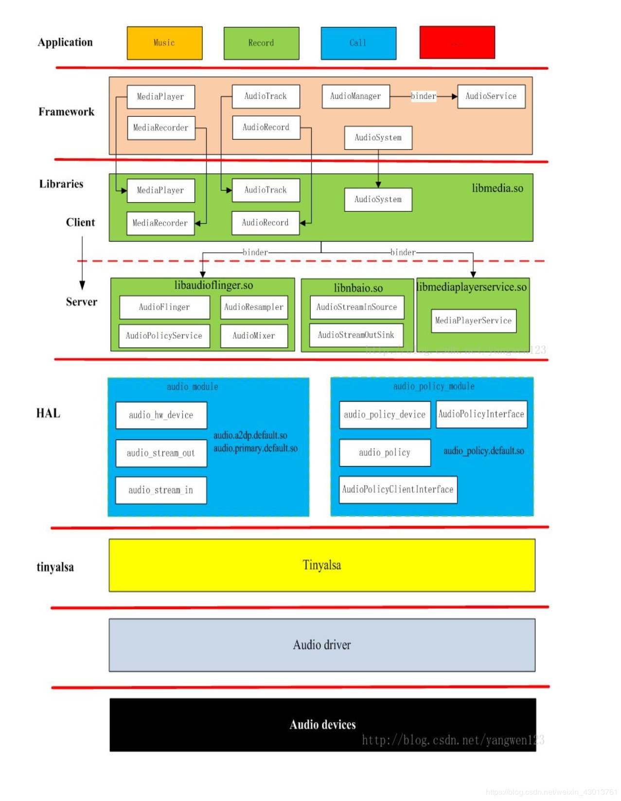
https://blog.csdn.net/weixin_43013761/article/details/89415156?depth_1-utm_source=distribute.pc_relevant.none-task&utm_source=distribute.pc_relevant.none-task

https://blog.csdn.net/zhuyong006/article/details/86609943

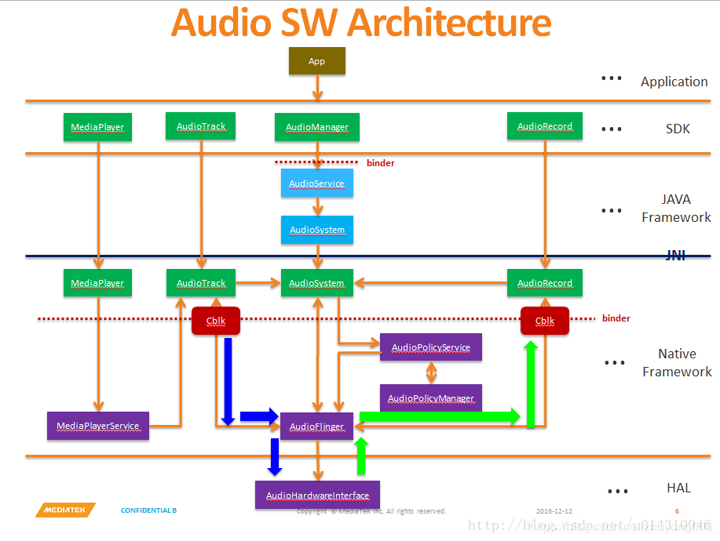

Block diagram of Audio data stream

AudioTrack plays three routines of audio data

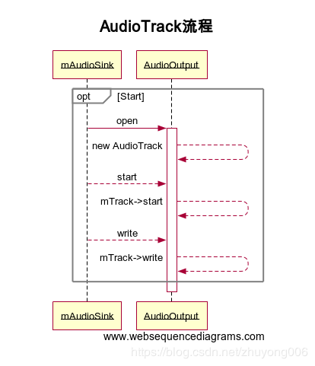

Qualcomm MSM8996 audio block diagram:

